End to End Technical Documentation

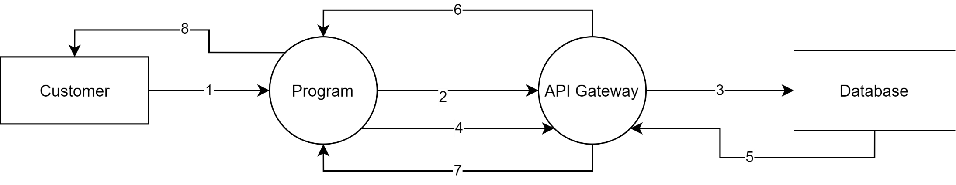

1. Input by customer into webpage form.
2. API call from program to create customer.
3. POST call to insert into database.
4. API call to get user details.
5. GET call to retrieve from database.
6. Success response from API gateway.
7. Rejection from API gateway as an exception.
8. Result displayed on webpage.